Experiment 8
Title

Student Counselling System using Zoho Creator (SaaS)

Aim
To create a simple cloud-based Student Counselling System using Zoho Creator, a SaaS platform.
Dashboard:
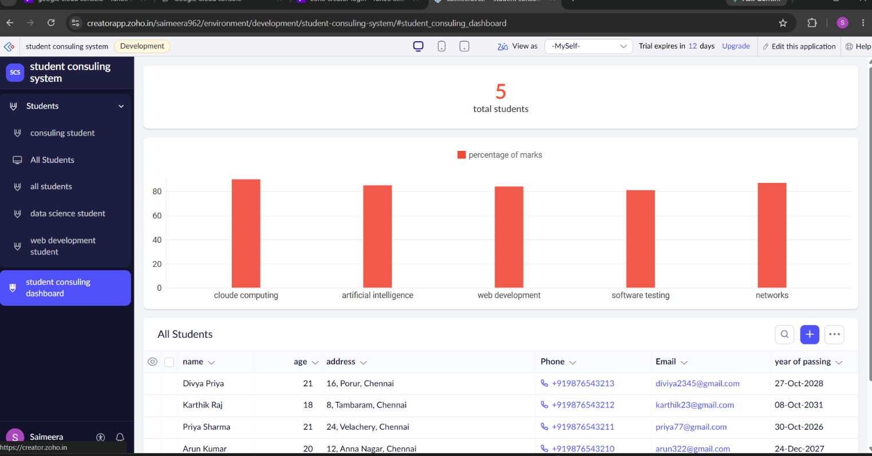
Report:
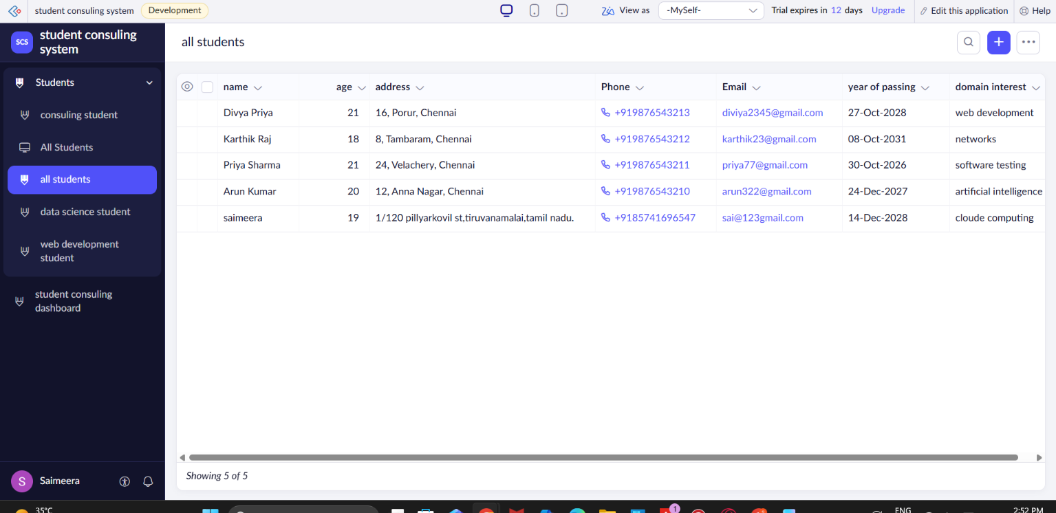
Form:


